Air Quality Prediction using Machine Learning

Project Id: AIML-15
Member 1:
Name : Mitushi Jain
Class Roll No : 54
University Roll No : 2028766
Section and Group : P(G2)
Member 2:
Name : Masoom Singh
Class Roll No : 53
University Roll No : 2028762
Section and Group : P(G2)
Member 3:
Name : Jiya Dhamija
Class Roll No : 47
University Roll No : 2028734
Section and Group : P(G2)

1.Problem Description………………………………….. 3

2.Architecture ………………………………………… 4

3.Models model….…………………………………… 5

4.Evaluation metrics used ………………………… 6

5.Preliminary Results and Visualizations…………………. 8

6.References……………………………………………….10

- Problem Description:

Air pollution has become a major environmental concern affecting human health and overall living conditions. With increasing industrialization, vehicle emissions, and changing weather patterns, air quality in many regions fluctuates frequently. Hence, there is a need for an intelligent system that can predict air quality levels in advance.
This project aims to develop an end-to-end machine learning system that predicts Air Quality Index (AQI) categories using pollutant concentration and meteorological data such as PM2.5, PM10, NO₂, CO, temperature, humidity, and wind speed. The system also uses date-time based feature extraction to improve prediction accuracy.
The dataset is preprocessed by handling missing values, cleaning data, and applying normalization or standardization. Feature selection techniques are used to identify the most relevant features for efficient and accurate prediction.
Machine learning classification models such as Logistic Regression, K-Nearest Neighbors (KNN), and Support Vector Machine (SVM) are used to classify air quality into categories: Good, Satisfactory, Moderate, Poor, Very Poor, and Severe.
Model performance is evaluated using accuracy, precision, recall, F1-score, confusion matrix, and ROC curve. This project demonstrates a complete pipeline from raw environmental data to final air quality prediction.

2.Architecture:
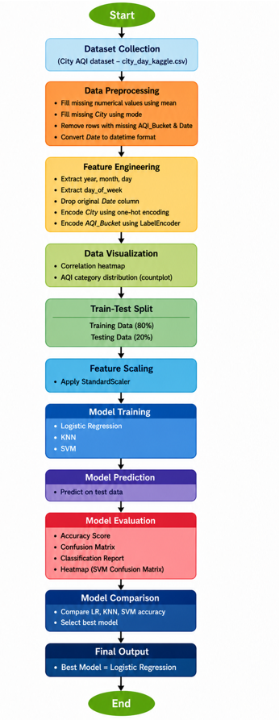

3.Models Used(Applied/ Planned):

1.Logistic Regression
Logistic Regression is used as a baseline classification model in this project. It is trained on the standardized environmental and meteorological features to predict the air quality category (AQI_Bucket). The model estimates the probability of each class and assigns the class with the highest probability as the final output. It is efficient, interpretable, and suitable for multi-class classification problems.

2.⁠ ⁠K-Nearest Neighbors (KNN)
KNN is applied as a distance-based classification algorithm. After feature scaling using StandardScaler, the model classifies each test sample by finding the nearest data points in the training set and assigning the most frequent AQI category among them. It helps capture local patterns in pollutant and weather data but can be slower for large datasets.

3.⁠ ⁠Support Vector Machine (SVM)
SVM is used to classify air quality levels by finding an optimal decision boundary between different AQI categories. In this project, it operates on standardized features to improve performance. SVM is effective in handling complex and high-dimensional data and generally provides strong classification accuracy for environmental datasets.

4.Evaluation metrics used:
To evaluate the performance of the machine learning models (Logistic Regression, KNN, and SVM), several standard classification metrics are used. These metrics help in understanding how well the models are predicting the air quality categories.

1.⁠ ⁠Accuracy Score
Accuracy measures the overall correctness of the model by calculating the ratio of correctly predicted observations to the total observations. It provides a general idea of model performance but may not be sufficient alone for imbalanced datasets.

2.⁠ ⁠Confusion Matrix
The confusion matrix is used to visualize the performance of the classification models. It shows the number of correct and incorrect predictions for each AQI category, helping to understand where the model is making errors.

3.⁠ ⁠Precision
Precision indicates how many of the predicted positive cases for a particular AQI category are actually correct. It is important when false positives need to be minimized.

4.⁠ ⁠Recall (Sensitivity)
Recall measures how many actual positive cases were correctly identified by the model. It is useful for understanding how well the model detects each air quality category.

5.⁠ ⁠F1-Score
The F1-score is the harmonic mean of precision and recall. It provides a balanced measure of the model’s performance, especially when class distribution is uneven.

6.⁠ ⁠Classification Report
The classification report combines precision, recall, F1-score, and support for each class, giving a detailed evaluation of model performance across all AQI categories.

5. Preliminary Results and Visualizations:

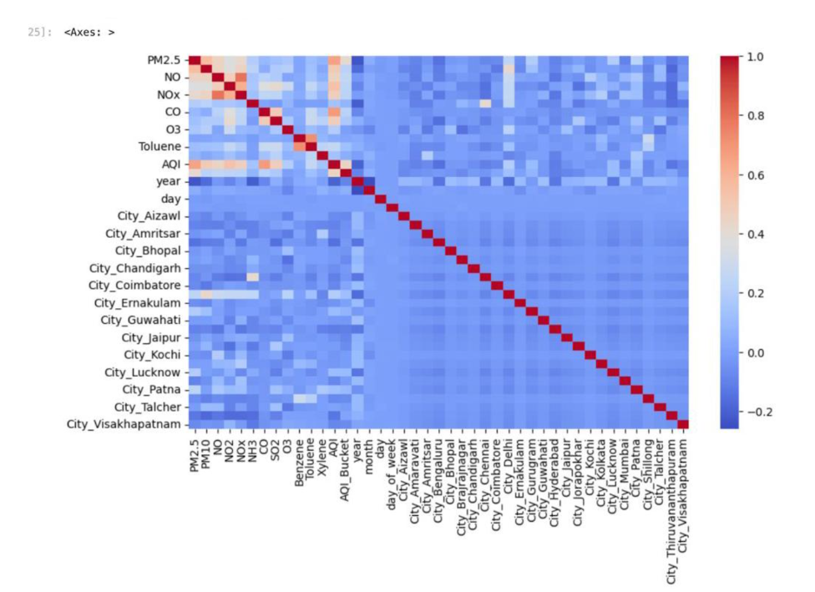
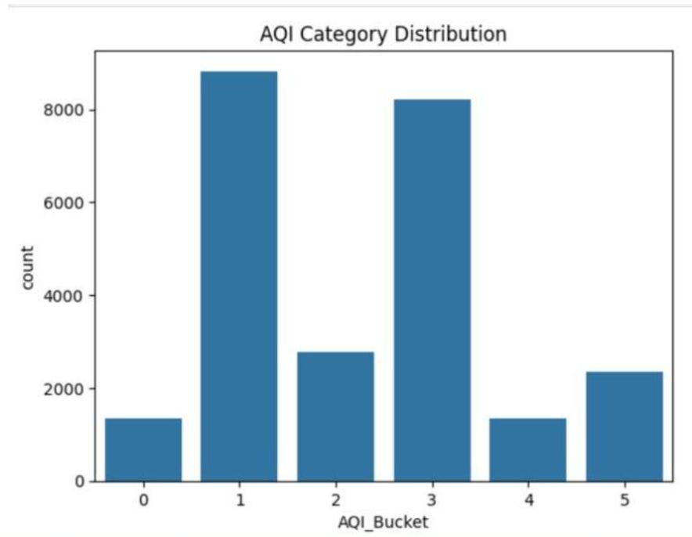

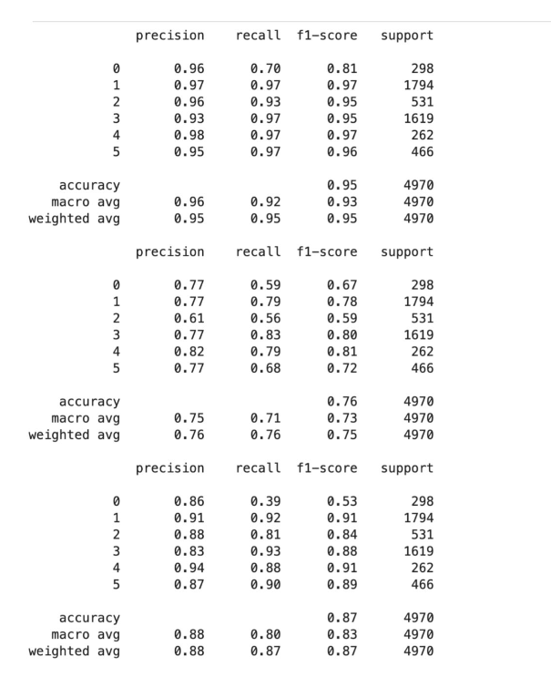

6. References:

1. Introduction to Machine Learning - Ethem Alpaydin

2. Pattern Recognition and Machine Learning - Christopher Bishop

3. Scikit-learn Documentation

